Homework M1: Introduction and Tool Landscape
Main goal is to build further on what was demonstrated during the practice
Prerequisites may vary between different tasks. You should adjust your infrastructure according to the task you chose to implement

Tasks
Choose and implement one or more of the following:
- Prepare a set of two virtual machines. One of the virtual machines should host the application, and the other – the database. Pick up one of the pairs – Python + Redis, Python + MariaDB, Go + Redis, or Go + MariaDB. You could implement it by following the manual approach or by automating the solution to some extent, including by using Vagrant
Note that the application should be adjusted a bit to be able to communicate with the remote database
- Prepare a set of two container images. One of the images should host the application, and the other – the database. Pick up one of the pairs – Python + Redis, Python + MariaDB, Go + Redis, or Go + MariaDB. Then spin up two containers out of them. You could implement it by following the manual approach or by automating the solution to some extent, including by using Vagrant
Note that the application should be adjusted a bit to be able to communicate with the remote database
Note that depending on the selection, one of the images could be a standard one (if using Redis)
Note that the Docker (or the container runtime/platform of choice) could be in a VM or on your host
- If NodeJS is your thing, try to create a version of the second NodeJS application but using MariaDB as a database. You are free to use either a pair of VMs, or a pair of containers (and container images)
Note that the application should be adjusted a bit to be able to communicate with the remote database
Note that the Docker (or the container runtime/platform of choice) could be in a VM or on your host
* Please note that even if you choose to implement more than one task, they may be quite independent and different. So, you may need to create a separate infrastructure (environment) for each or at least clean it every time

Proof
Prepare a document that shows what you accomplished and how you did it. It can include (not limited to):
- The commands you used to achieve the above tasks
- A few pictures showing intermediary steps or results

- For the first task of this challenge I have dicided to use the machine used in practice and created a copy of it to help with the execution
      - Setting up the machines
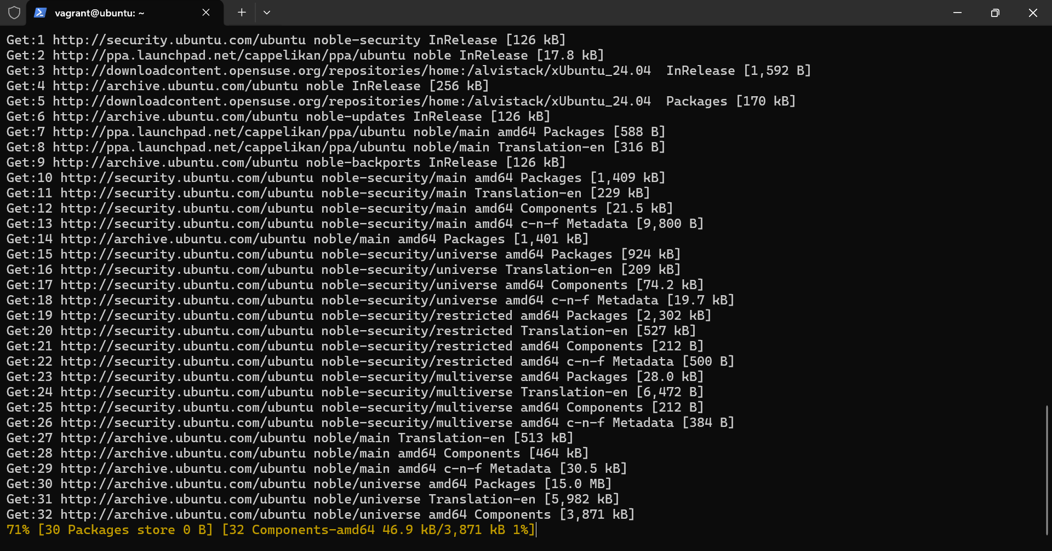
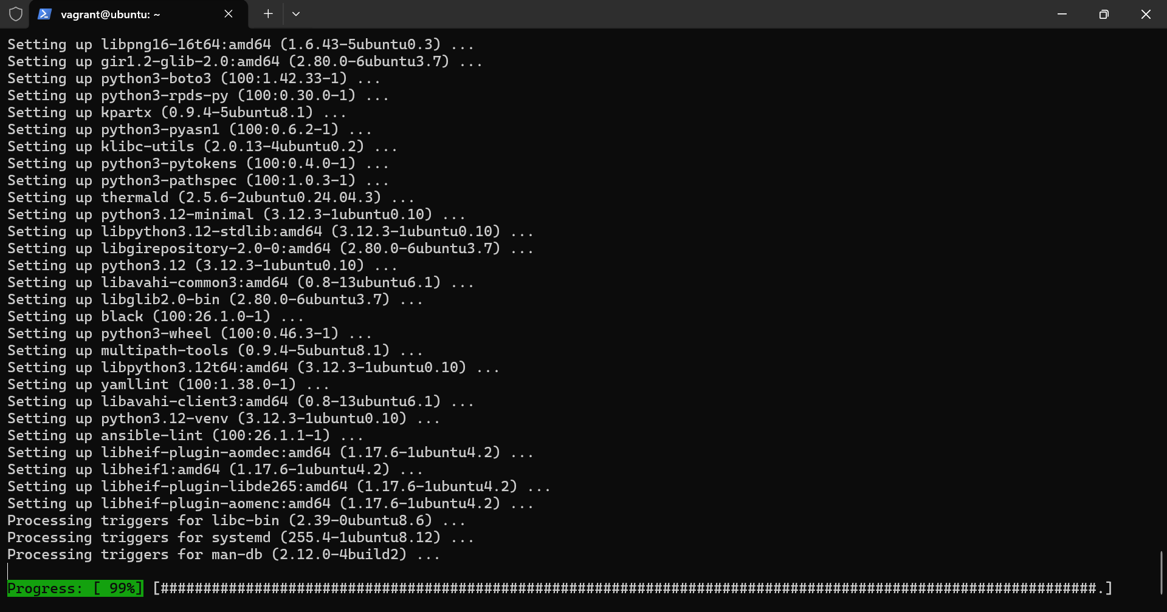
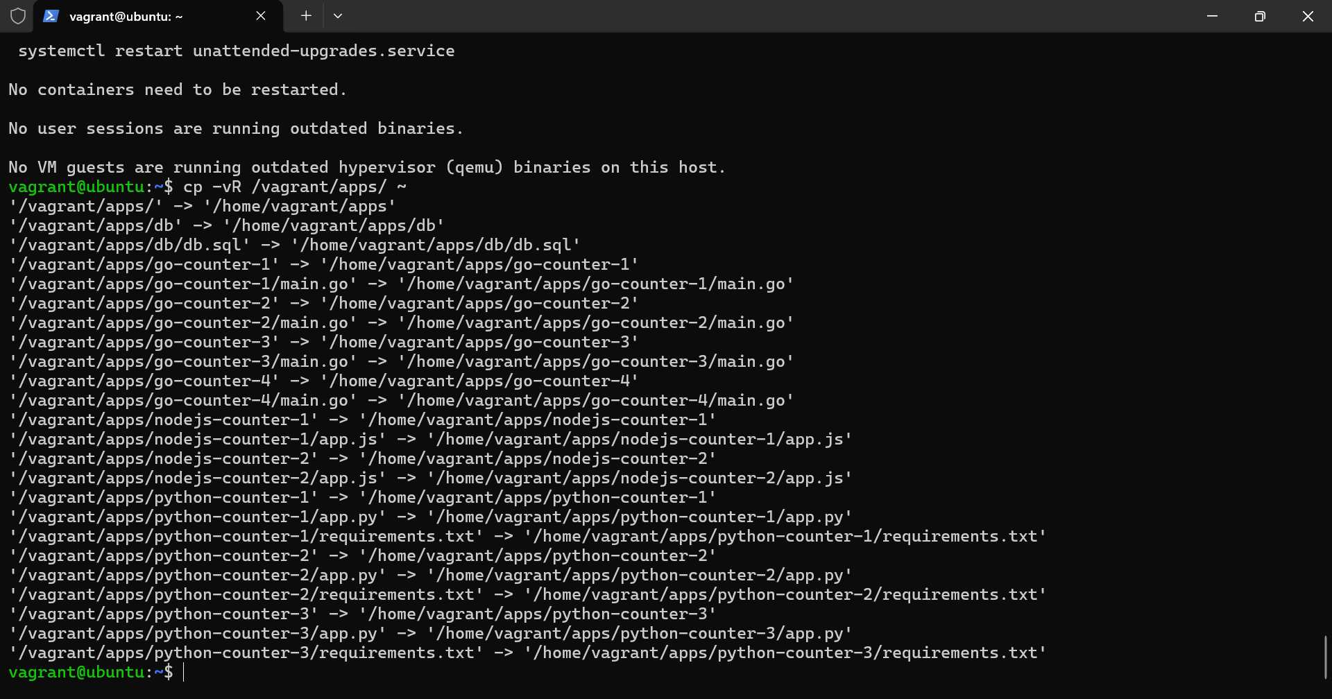
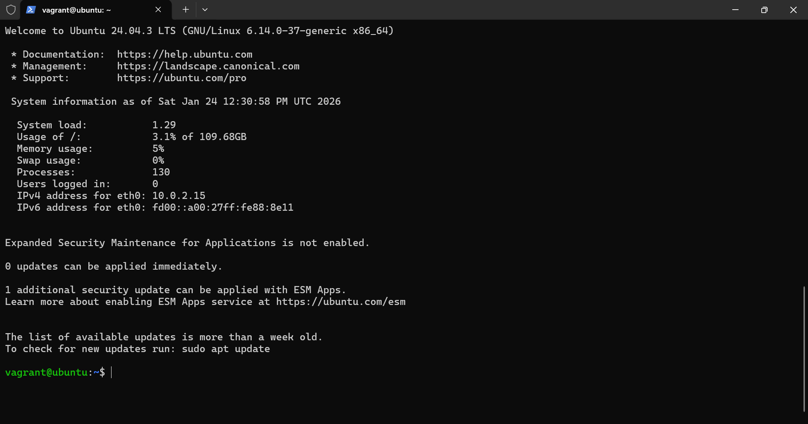

      - Installing the MariaDB database
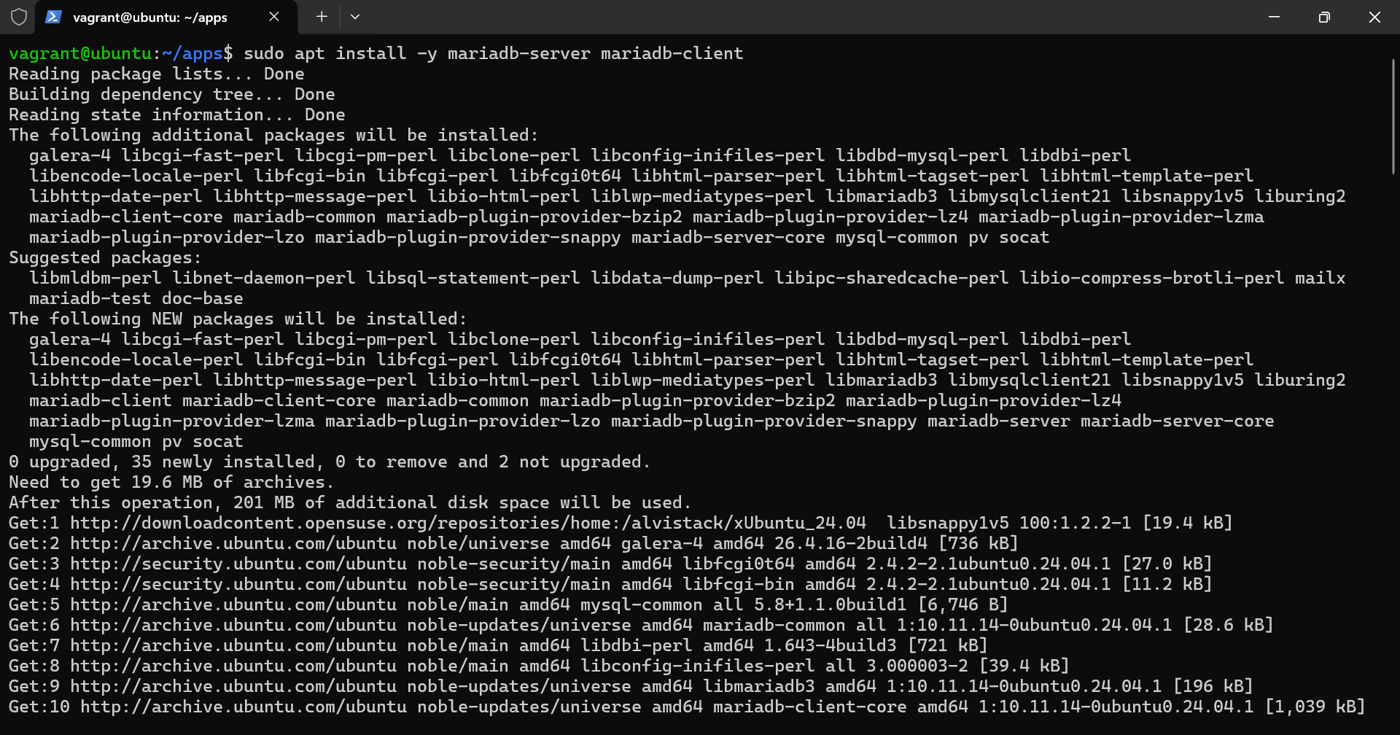
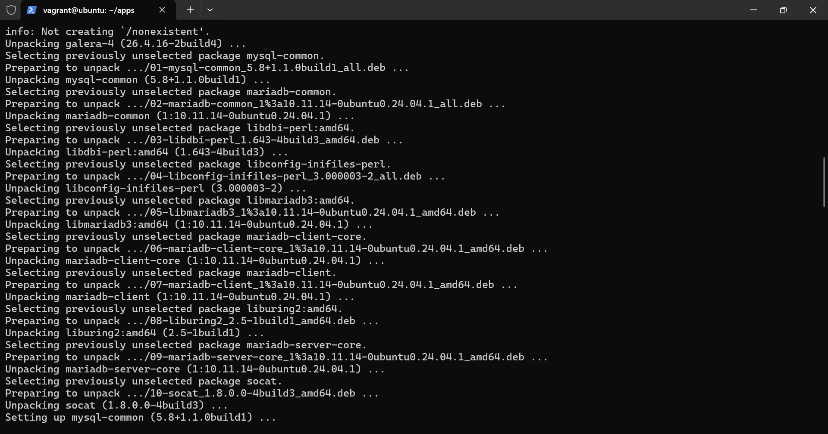
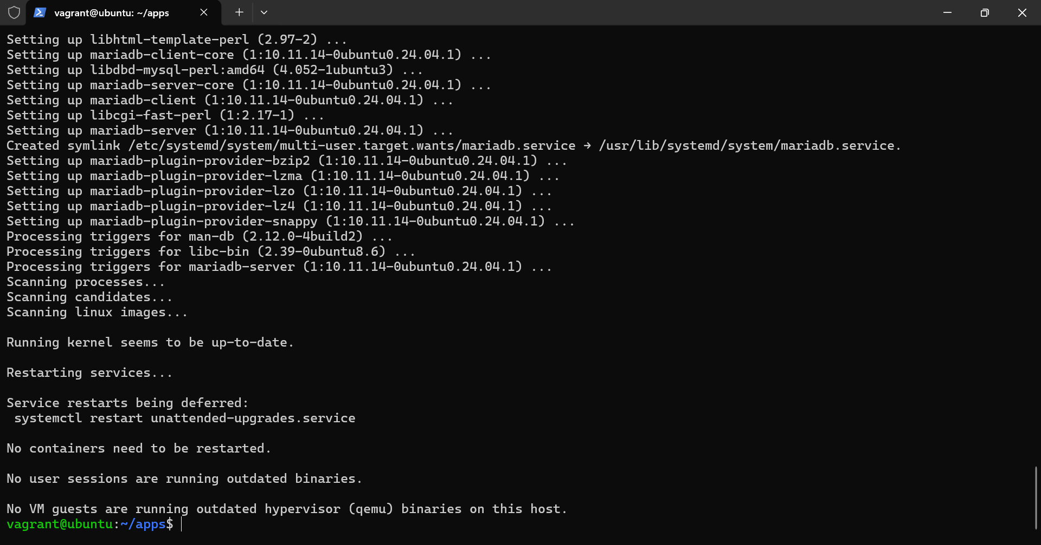
      - Securing the mariaDB database
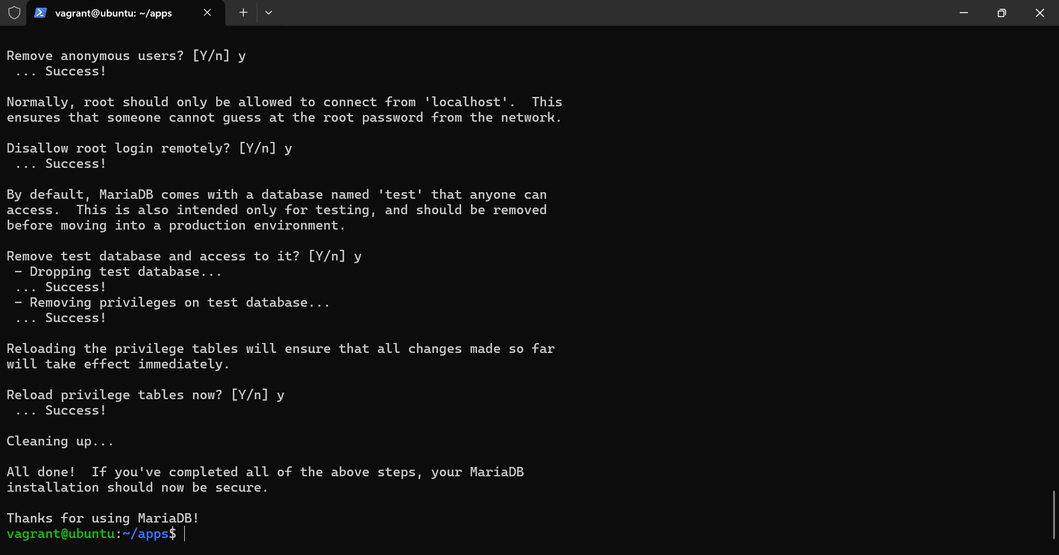
      - Seems that the database server is working properly
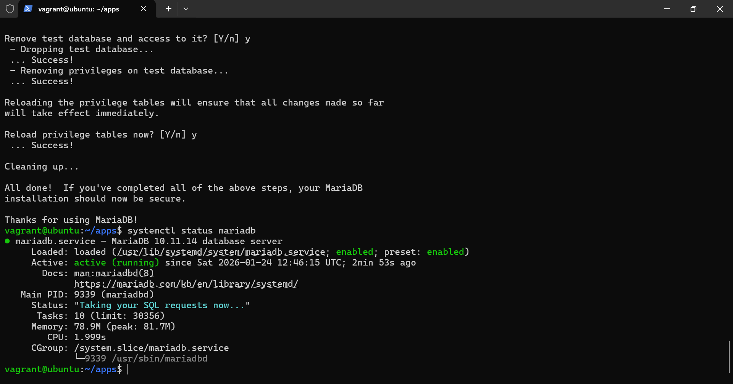
      - Prepping the app on the other machine. Creating virtual environment, activating it and installing dependencies in the app
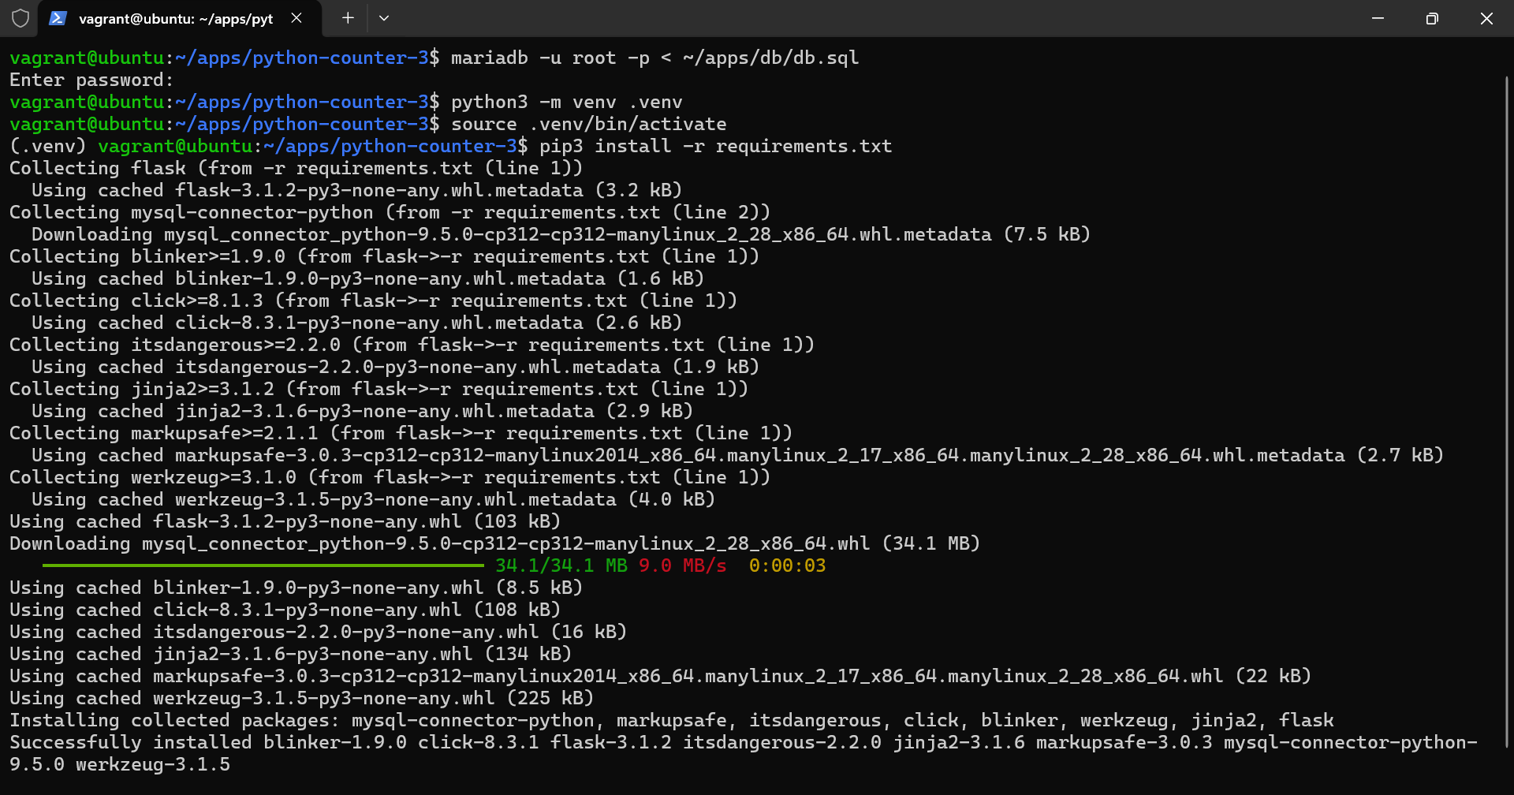
      - Running the app and checking that it works both in the browser and the console
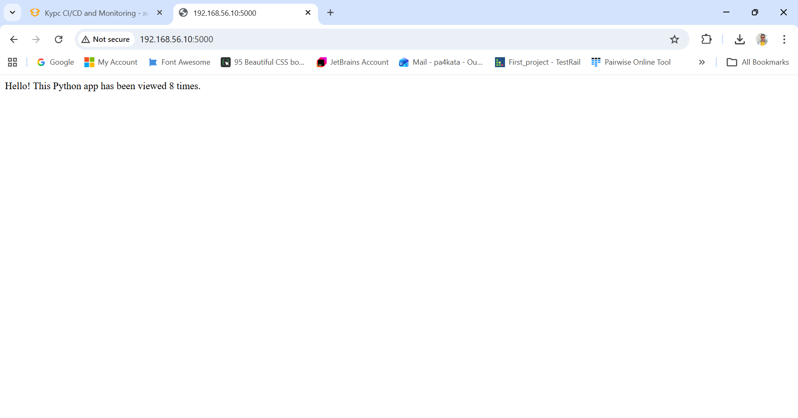
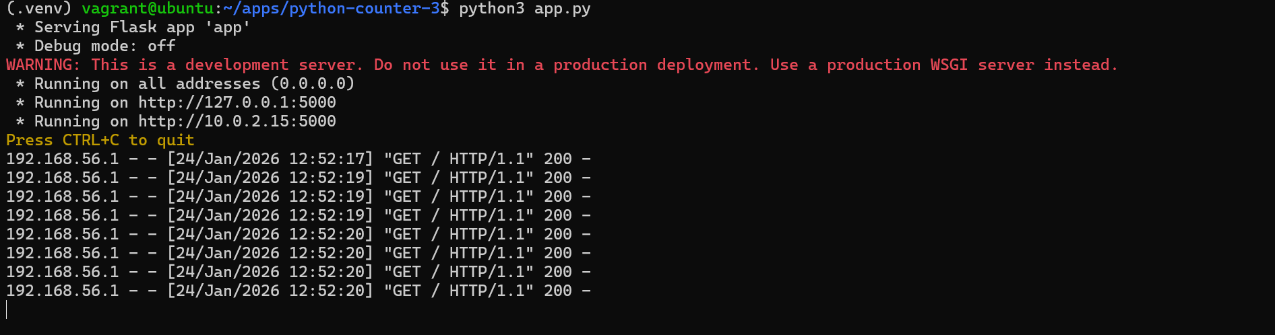

- Trying to do the NodeJS version
- Installing NVM and adjusting the environment and making it available for current session
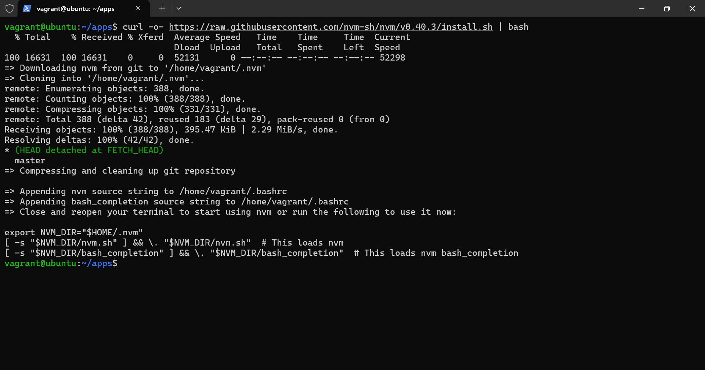
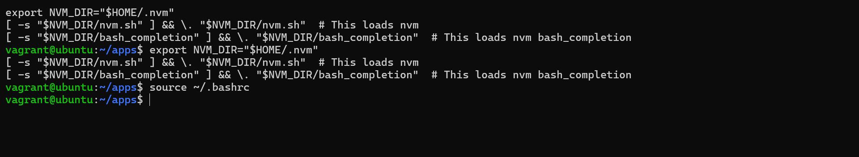
- Installing MariaDB and securing it
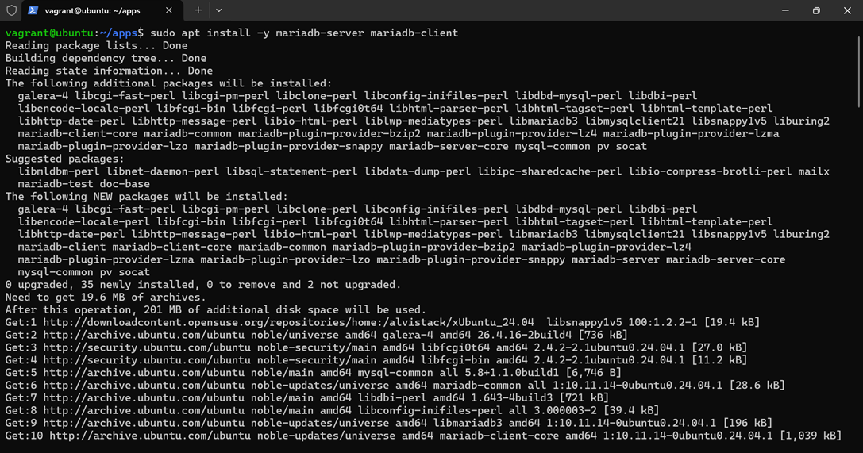


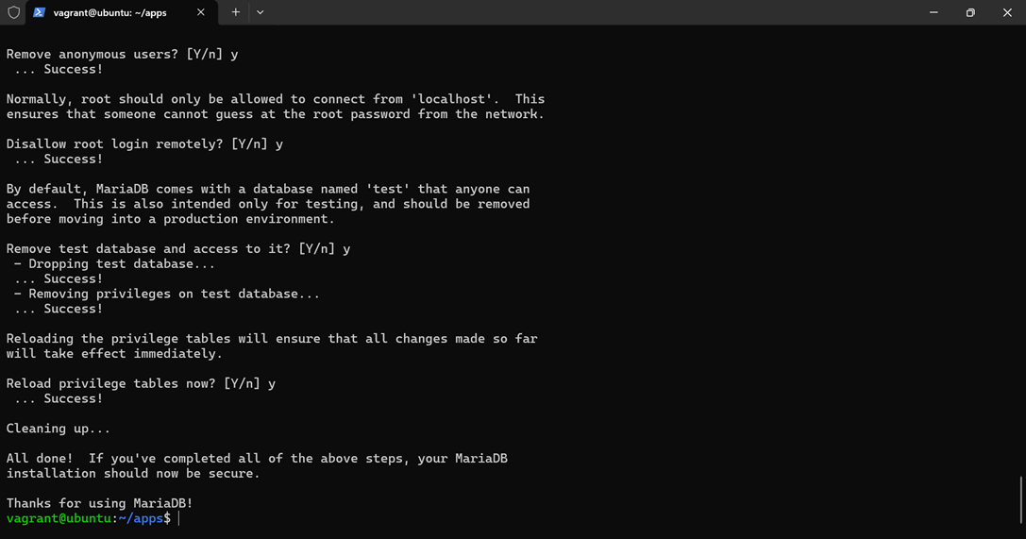
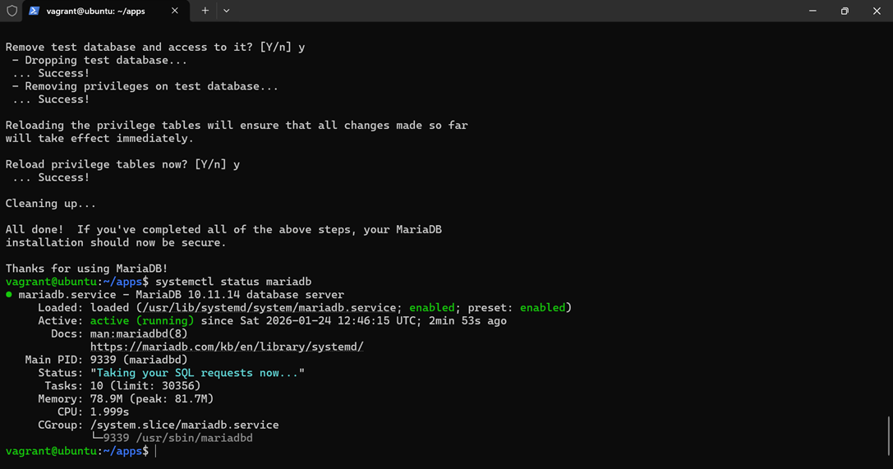
- Installing Node
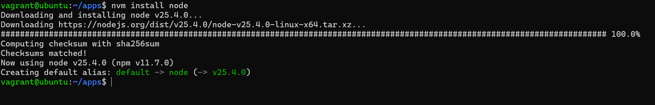
- Creating package.json file
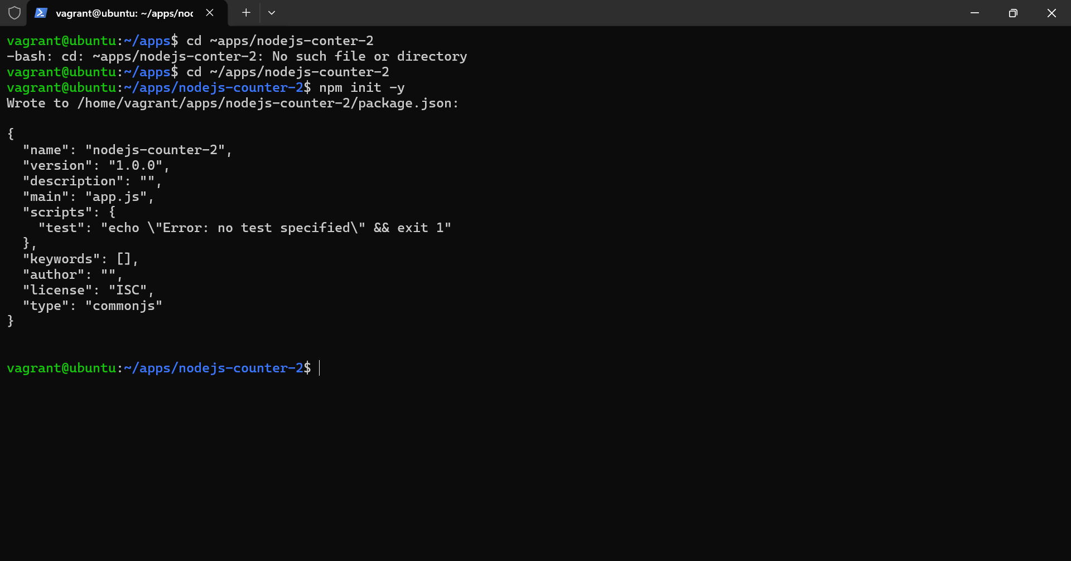
- Installing dependencies for MariaDB and running the application
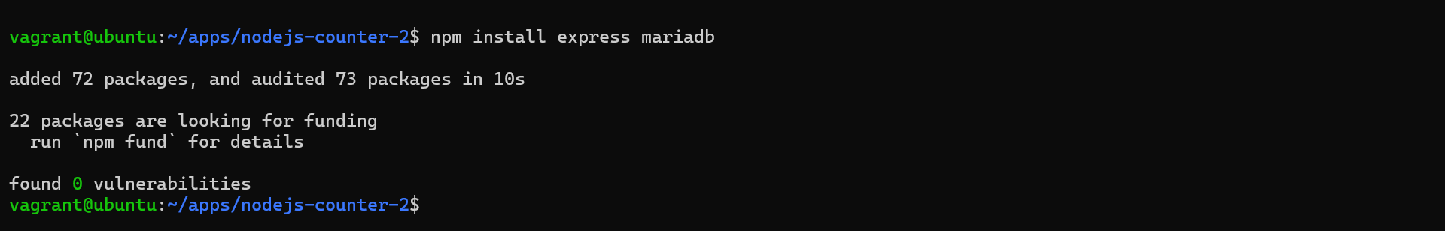
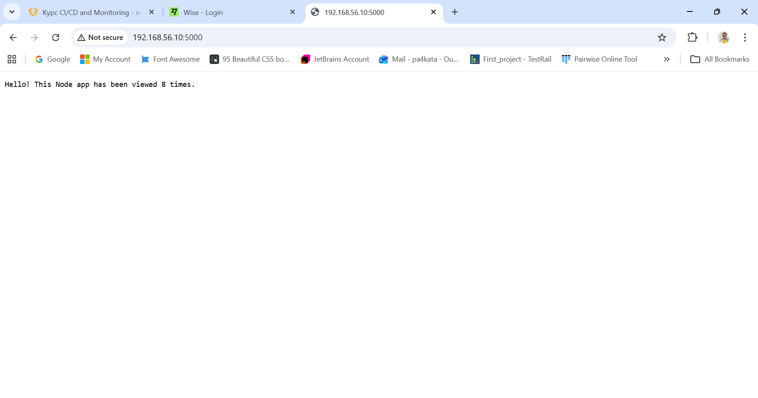
- Going the container way
- Updating the packages and installing prerequisites for docker
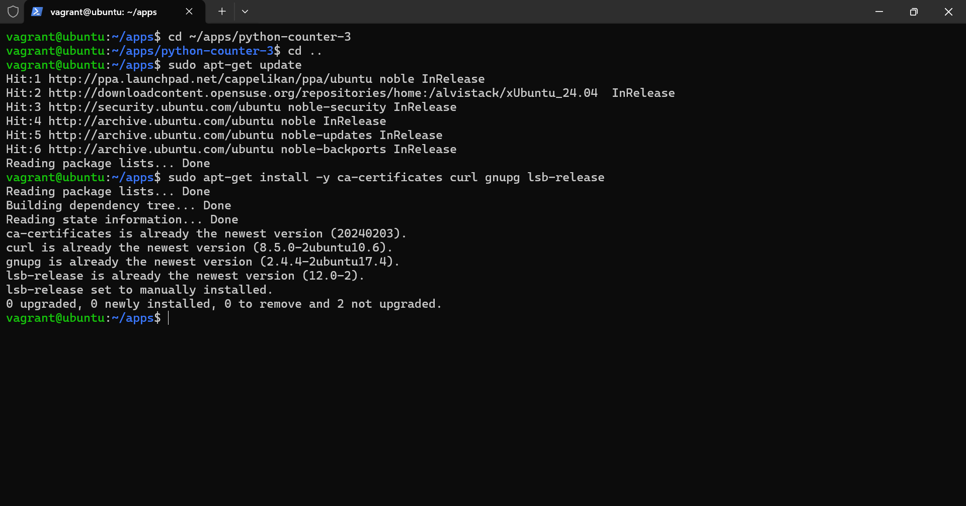
- Adding docker repository and official docker gpg key
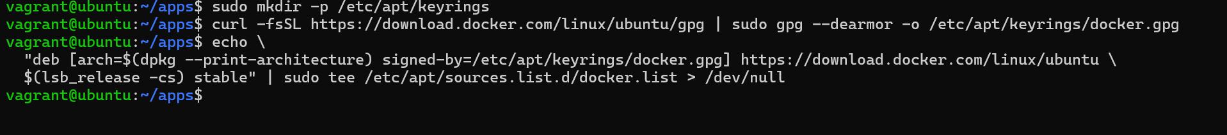
- Installing docker components
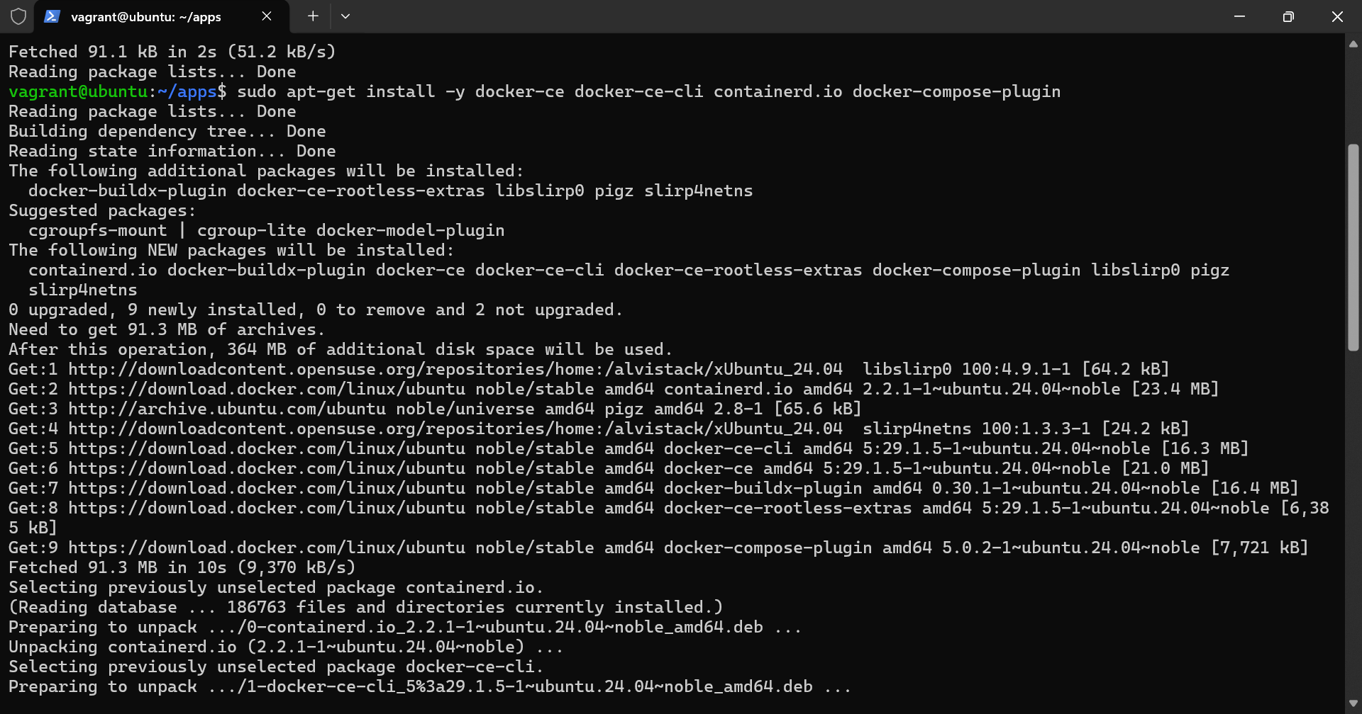
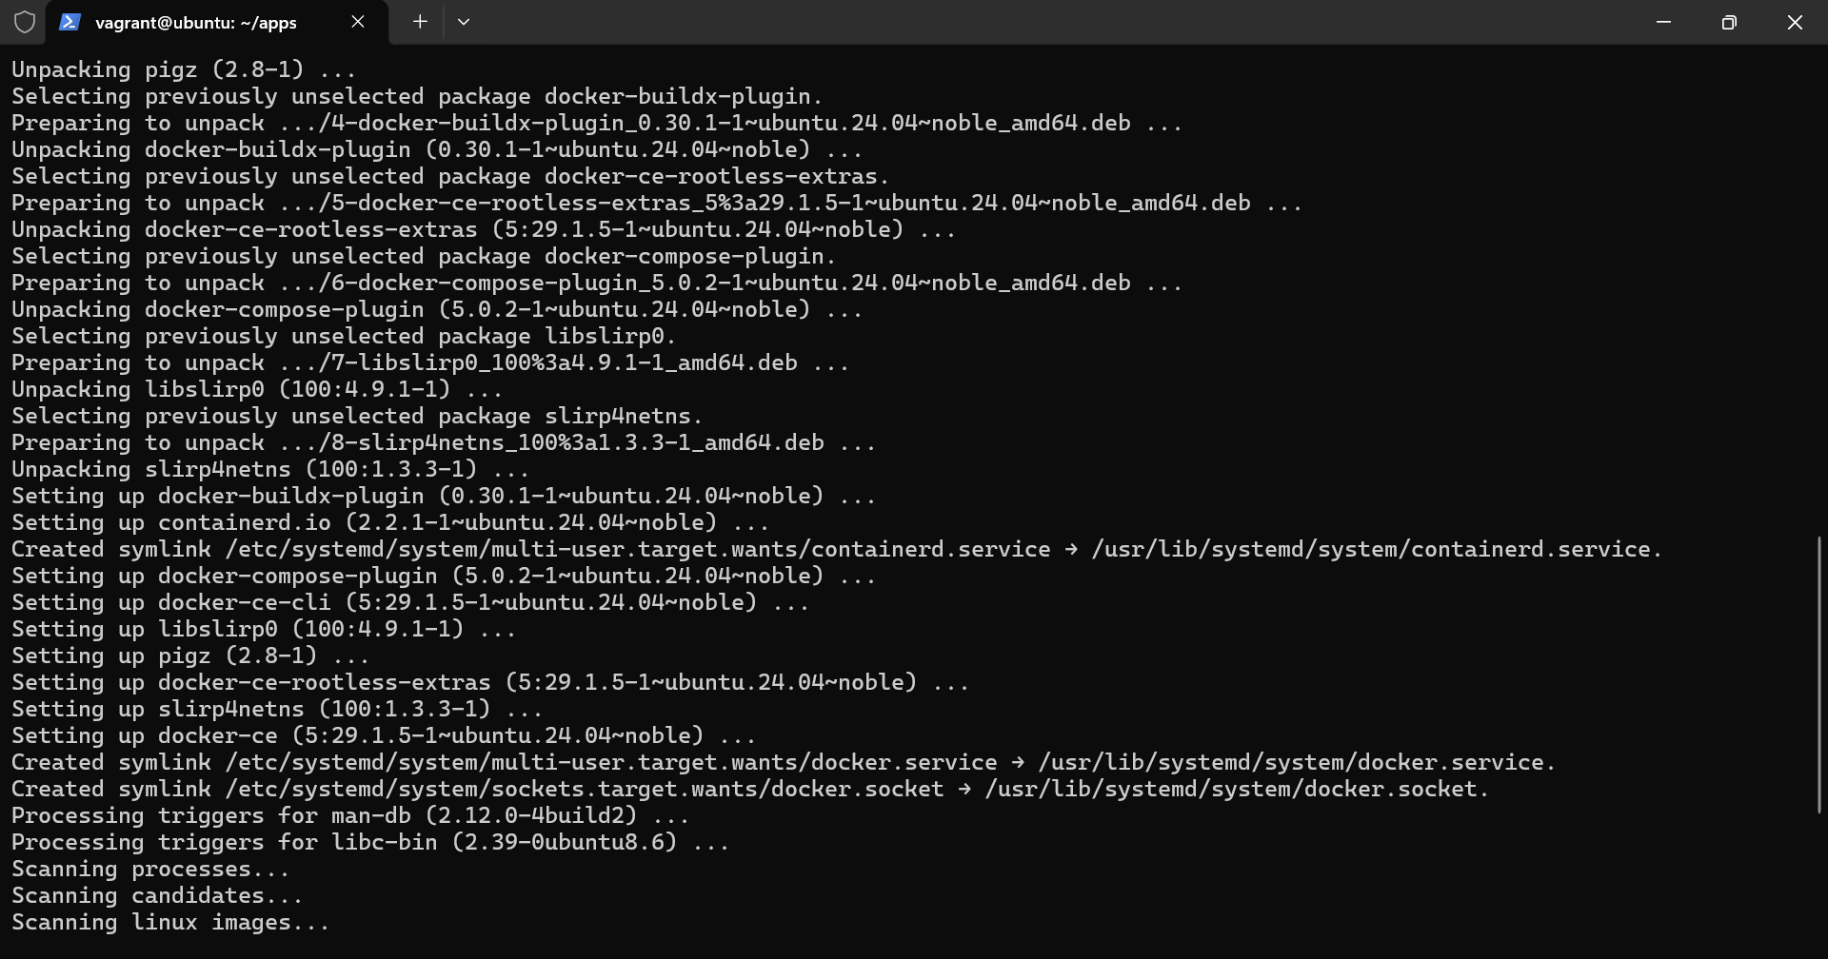
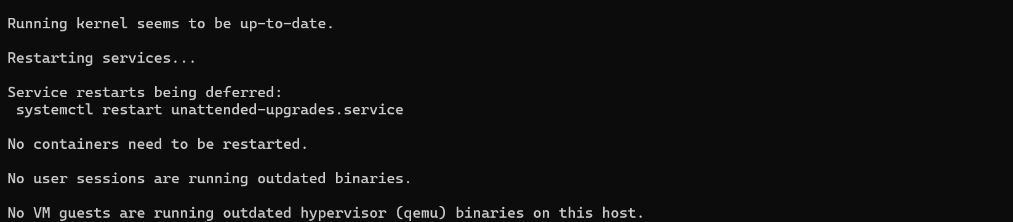
4.Checking that all docker components are installed successfully and creating dockerfile for the application
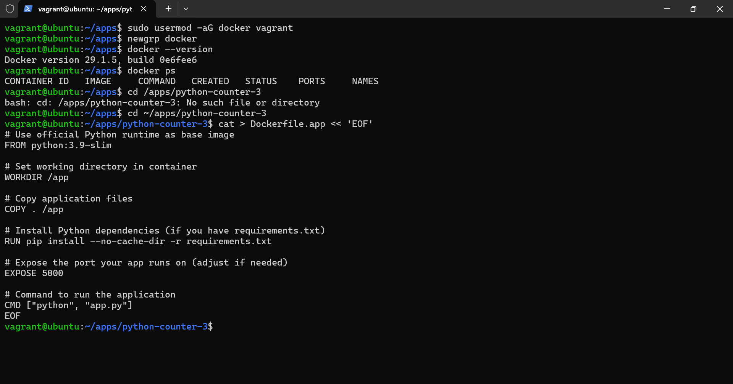
5.Creating docker file for the database
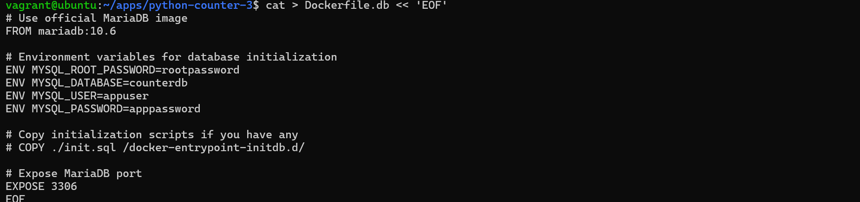

6.Building the docker images for both the database and the application
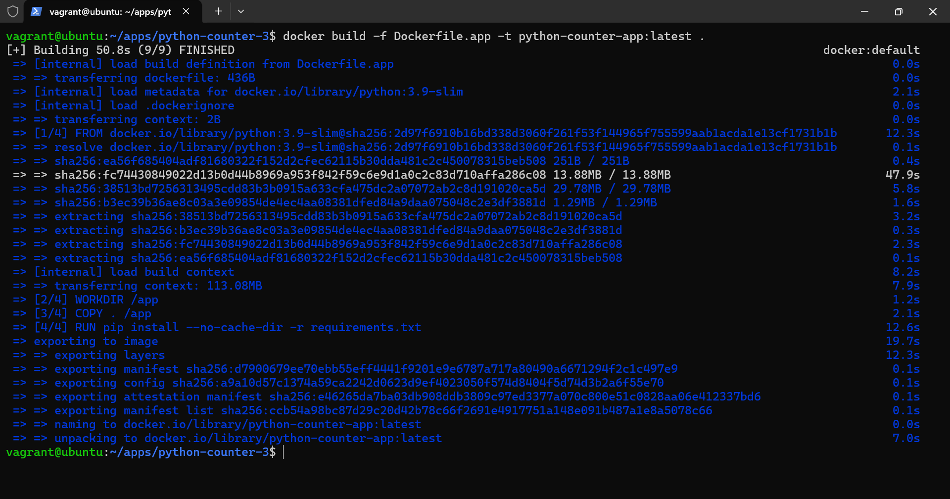
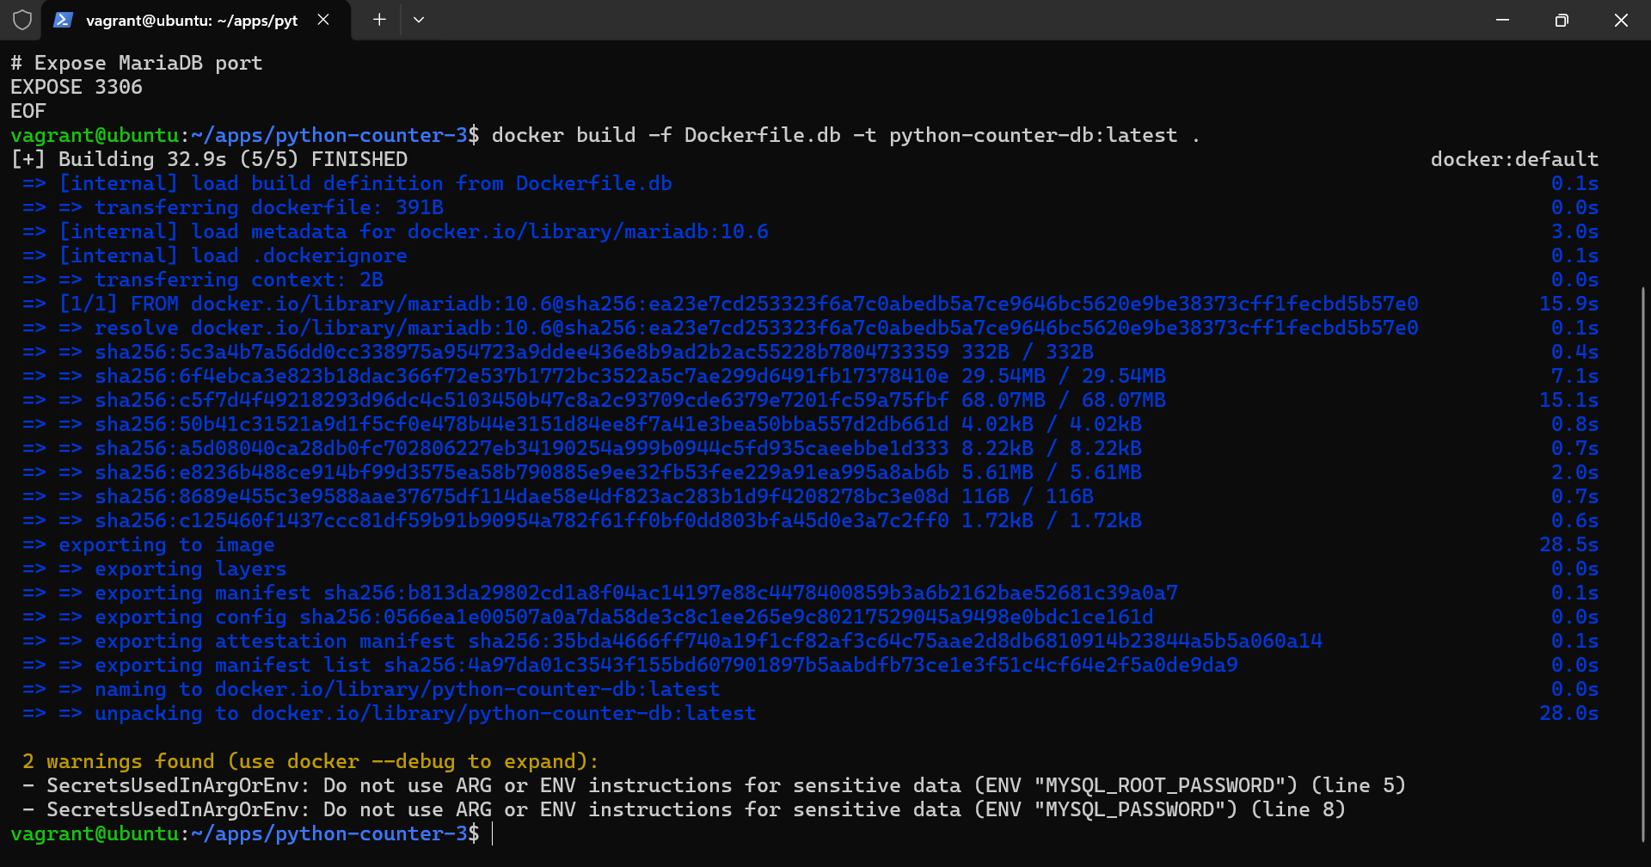
7.Running the images
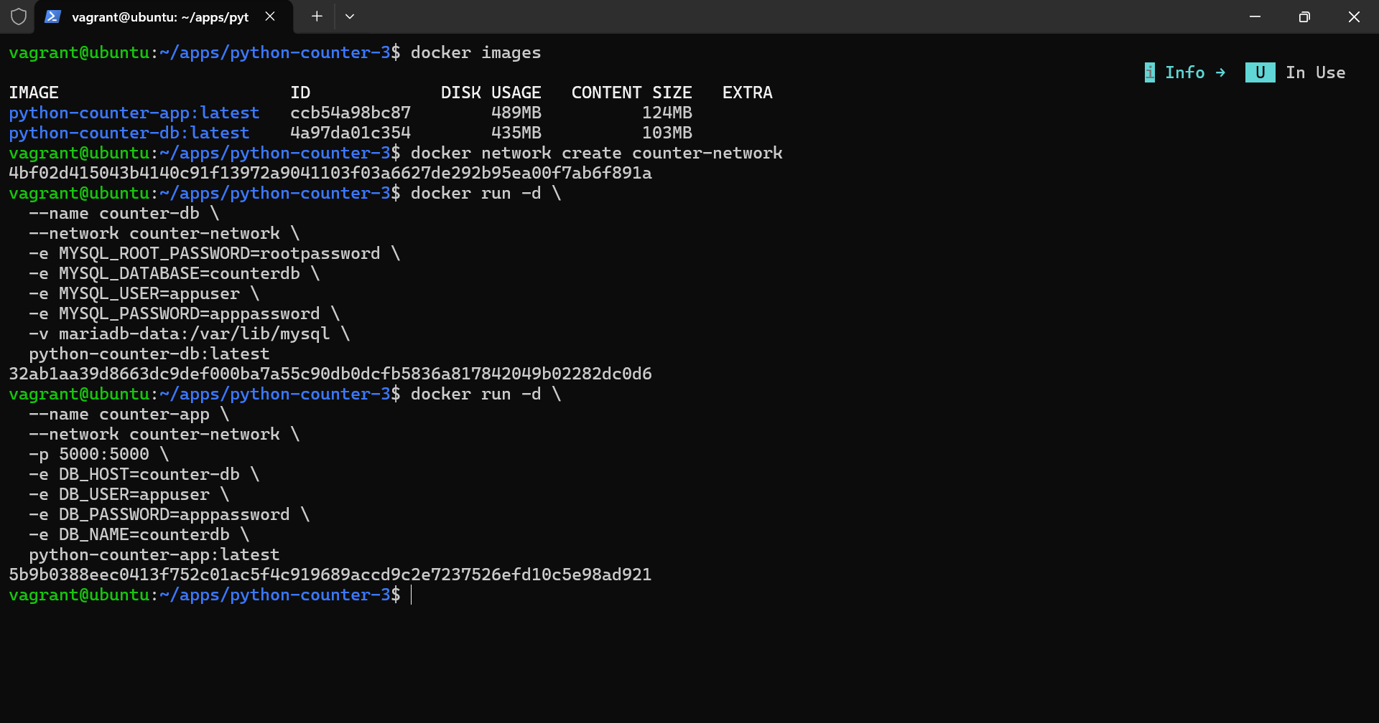
8.Checking if everything is running

